

IS4432 Systems Design (Sem B 10/11)
Course Instructor: Janet Yu

University Retail Food Services Vendor
Accounts Payable System (VAPS)

Team 3
Student Name | Student ID
WANG Meng | 40033326
Li Bowen | 40033340
CHENG Wan Wing | 51464445
ZHAO Kejun | 40033338
ZHANG Yijie | 51436274
MENCHACA Joaquin | 40034231

- Background Introduction
In order to better serve its students, a major university contracted with several commercial vendors to operate on campus. This arrangement basically allows the university to operate several well-known food franchisees in multiple locations on campus. Franchisees provide the university with a list of approved vendors, such as Blimpie, Chick-Fil-A, Pizza Hut and Cappuccinos, who provide each store with approved products. Besides, the university offers staff and administrative support for this operation. One important part of the support is to pay authorized vendors for purchases of food and associated products.
Now, the payment issues to the vendors are handled by a small group of people in University Finance and Accounting Department which consist of the comptroller (Barbara), the accounts payable supervisor (Van), the accounts receivable supervisor (Maria), the retail vendor account(Javier)and other general accounting functions.

  - Problems
The major responsible department for the payment issues to the vendors is University Finance and Accounting Department, which have limited staff. Besides, the Retail Food Service Vendor Accounts Payable System (VAPS) now is primarily a manual process, only limited computerized support is available.
Problems appear in the legacy system:
- Late processing of invoices:
  - Complaints from vendors due to late payments
  - Increase in late payment fees charged to the university
  - Loss of vendor discounts for early payment of invoices
- Inefficient generation of management reports
  - Manual computation of data needed
- Duplication of payments
- Multiple entry of data (sometimes with error)
- Inefficient use of information systems
- Inefficiently assess the status of accounts payable
- High training cost
- Current configuration unlikely to support newer applications

  - Opportunities
An integrated system is in need for performance improvements. The system will provide opportunities as shown below:
- Timely processing of invoices:
  - Invoices received through the system
  - Franchisees confirm invoices after goods received
  - Accounts payable clerk processes invoice information and prepare payment information
- Efficient generation of management reports
  - Automated computation of data needed by the system, e.g.:
- Total paid out by each franchisee
- Franchisee total broken down by university account
- University detail and summary by university account
- Vendor totals
- Total for each account etc.
  - Able to provide an ad hoc query facility
- Accuracy of payments
  - Timely generation of request issuance
  - Issuance officer issues checks by updating payment information
  - Able to match completed request issuances with outstanding request issuances
- Elimination of duplicate data entry
- Store vendors, franchisees, product types, invoices, request issuance information on the system
- Low turnover rate and training cost
- User-friendly system interface design
- Ease of use of the system
- Simple job processing

- Assumption
  - There is valid contract between vendors and franchisees for purchases.
  - Vendors send only delivery notes along with the products delivered, without hard-copy invoices anymore.
  - The system is reliable and vendors are not required to confirm supply request details through the system.
  - Fully or partially shipment is allowed.
  - Scheduled Payment Date on the Request Issuance form is calculated by the system automatically by a pre-defined function, i.e. the invoice day.
6. Franchisees need to update supply request information daily to make sure there are enough inventories for their business operation.
7. Franchisees already have a list of quoted price for the products from the vendors.

- Use Case Diagram

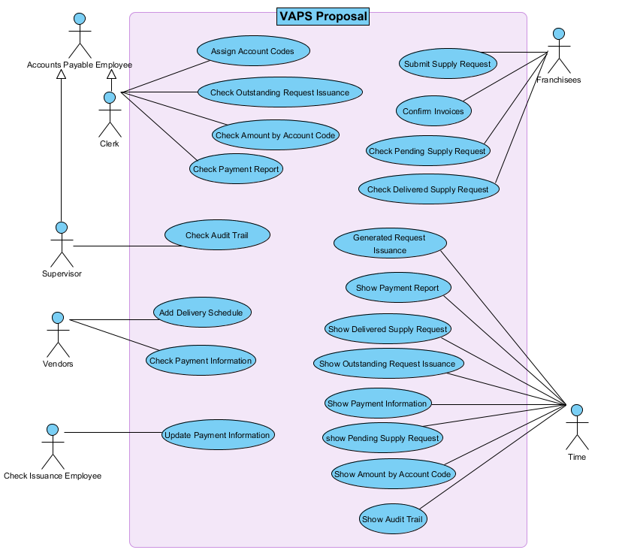
Fig 2.1

The Vendor Accounts Payable System (VAPS) is designed to serve vendors, franchisees, accounts payable employees and check issuance employees as well.
According to the system requirement proposal, franchisees are going to submit supply request through the system, then vendors will generate invoices by adding delivery schedule. Once franchisees receive goods, they will confirm invoices generated by the system and simultaneously the actual delivery details are automatically updated. Next, the accounts payable clerk receives alert of confirmed invoices and assigns account codes to the invoices accordingly. Then, VAPS generates request issuance for check issuance employees. After alerting by the system, check issuance employee will then update payment information which includes date payment approved and check number in the system.
Additionally, the system can generate ad hoc reports to different users upon request. For example, it can show outstanding request issuance if the accounts payable clerk needs to check outstanding request issuance. Moreover, accounts payable supervisor can check audit trail which include all activities performed in the system at different time stamp through the system.

Use Case name | Franchisee Confirm Invoices
Primary actor | Franchisee
Pre-conditions | Franchisee is identified and authenticated.
Post-conditions | Invoices are confirmed and confirmation message is sent to Accounts Payable Office.
Trigger | Franchisees want to ensure the correct amount is charged to the actual quantity received and each price charged is the quoted price given by vendors.
 | 1. | Franchisee provides the vendor number and vendor name;
 | 2. | System presents the invoice(s) generated by the vendor;
 | 3. | Franchisee confirms the invoice;
 | 4. | System sends an invoice confirmation message with confirmation reference number.
Extensions | 2a. VAPS cannot find the corresponding invoice of the vendor number provided.  2a (1) System asks the franchisee to provide a correct vendor number.  4a. The actual delivery inventory does not match with the invoice, franchisee declines the invoice.  4a (1) System asks the franchisee to provide decline reason.
3.1 Use Case Descriptions - Franchisees confirm invoices
Table 2.1

3.2 Sequence Diagram- Franchisees confirm invoices
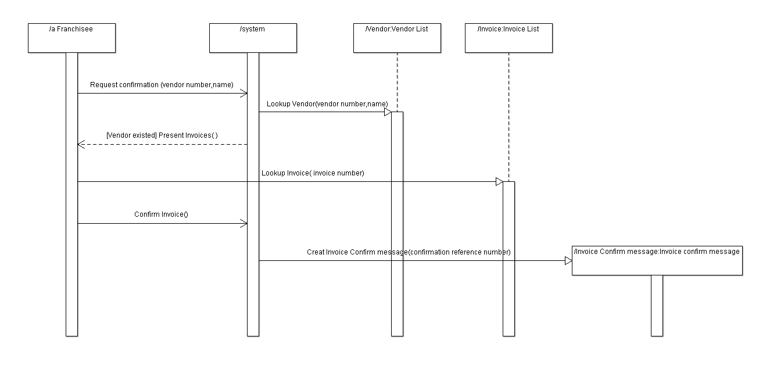

Fig 3.1
3.3 State Machine – Invoice
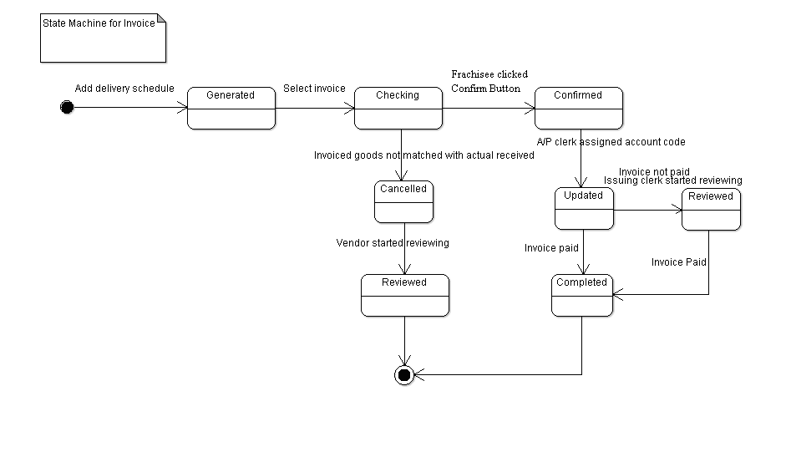
Fig 3.3
Firstly, after vendors sending out goods and update delivery schedule in the system, the sales invoice is generated and sent to franchisees automatically. Then franchisees select invoice for checking details. During the state of checking, franchisees check to see if the product type, quantity and amount on the invoice are matched with exactly the goods received.
If matched, the invoice is to be confirmed. Then account payable clerk can assign account code on the confirmed invoice. The invoice is updated and alert message is sent to check issuance clerk for preparing payment information. After payment is done, then the invoice is confirmed. However, if invoice is not paid, issuing clerk can review the invoice to check the matter and prepare to pay the invoice. Until the invoice is paid, then it can be said complete.
If not, the invoice is cancelled. The system then alerts the vendors about the invoice cancelled. After that, invoice is reviewed by vendors and vendors will check what is going on and then sent delivery goods according to relevant supply request and a new invoice is going to be generated.

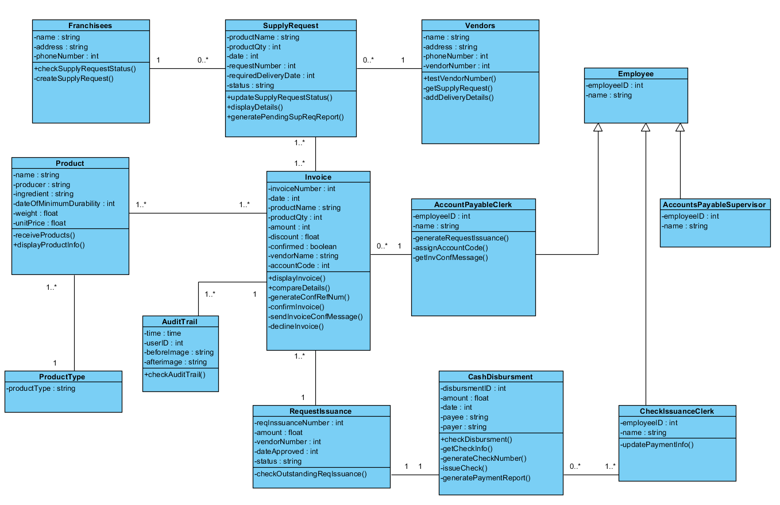
Fig 4.1
4.1 Class Diagram
With the case description and the use case diagram created before, we generate the corresponding class diagram as followed, including all the classes, attributes, operations and relationships that support the use case diagram. In addition, we put more emphasis on the functionality – Franchises confirm invoice – which is assigned to our team.

To complete the functionality, several operations are needed in the system.
- searchInvoice()
- displayInvoice()
- confirmInvoice()
- declineInvoice()
The workflow is:
Franchisees will input specific vendor number, vendor name, invoice number and date by using testVendorNumber () operation. If the input is incorrect, no result is returned; if the vendor number is correct, the window will show short list results on the screen.
Then the user will click on one certain invoice to display the details by using displayInvoice ().
If the user wants to confirm the invoice, he may click the “confirm” button. This is confirmInvoice () operation.
If the actual delivery and invoice do not match or there is any other problems, franchisees may decline the invoice through declineInvoice () operation. Decline reasons have to be typed into a window, and they will be sent to vendors.

4.2 Operation Description:

Name of Class | Operations | Brief Description
Franchisees | createSupplyRequest() | Create a supply request and store it automatically.  Input: supply request details including vendor name, vendor number, products, quantity and delivery date.  Return: a supply request number.
Franchisees | checkSupplyRequestStatus() | Call getSupplyRequestStatus() of Supply Request class, and display the information in given form.  Input: supply request number.  Return: the current status such as pending, processing, packing, delivered, completed, etc.
Supply Request | generatePendingSupReqReport() | Go to the supply request database, sort the supply request by status, and generate pending supply request report.  Input: Null.  Return: Null
Supply Request | updateSupplyRequestStatus() | Call setSupplyRequestStatus () of Supply Request class to update supply request status.  Input: supply request number  Return: value as pending, processing, delivered or completed.
Vendor | receiveSupplyRequest() | Automatically reach the mailbox in the system, receive supply request and display them on screen.  Input: Null.  Return: Null.
Vendor | addDeliveryDetails() | Add delivery details and set delivery schedule.  Input: Convert product information from the supply request into delivery details automatically, and allow the vendor to make some modifications if partially delivery is needed.  Return: delivery schedule.
invoice | searchInvoice() | If the input is incorrect, no result will be returned. If the vendor number is correct, the window will show short list results on the screen.  Input: vendor number, vendor name, invoice number and date.  Return: Null.
invoice | displayInvoice() | User will click on one certain invoice on the shortlist to display the details.  Input: Null.  Return: Null.
invoice | comfirmInvoice() | The user may click the “confirm” button to confirm the invoice displayed by using displayInvoice().  Input: Null.  Return: Null.
invoice | declineInvoice() | Decline invoices from vendors if the actual delivery and invoice do not match. In addition, franchises have to provide decline reasons.  Input: decline reasons.  Return: Null.
Account Payable Clerk | sendReqIssuance() | Get the invoice details from the database using the invoice number, and then call the constructor of Request Issuance class to create a request issuance, and store it in the database.  Input: invoice number.  Return: Null.
Account Payable Clerk | assignAccountCodes() | Call setAccountCode () of Invoice class, and assign the account code.  Input: invoice number.  Return: account code.
Account Payable Clerk | getInvConfMessage() | Get invoice confirmation message with confirmation reference number from the database.  Input: Null.  Return: invoice confirmation message with confirmation reference number.
Request Issuance | checkOutstandingReqIssuance() | Get the request issuance details from database, and sort them by status, and show summary and details of outstanding request issuance information on screen.  Input: Null.  Return: Null.
Cash Disbursement | checkDisbursement () | Get disbursement information in history from the database, and display it on screen.  Input: Null.  Return: Null.
Cash Disbursement | getCheckInfo() | Get the amount of check from check issuance clerk.  Input: check number.  Return: the amount of check.
Cash Disbursement | generateCheckNumber() | Generate a check number for each check.  Input: Null.  Return: check number.
Cash Disbursement | issueCheck() | Issue check from particular bank account.  Input: check number, bank account.  Output: check details.
Cash Disbursement | generatePaymentReport() | Get payment information from the database and generate payment report.  Input: Null.  Return: payment reports.
Check Issuance Clerk | updatePaymentInfo() | Update payment information in system.  Input: payment information.  Return: Null.
Product | displayProductInfo() | Get product information from the database, and display the information on screen, including product number, name, price and vendor.  Input: product number.  Return:Null.
Audit Trail | checkAuditTail() | Get audit trail details from the database, and display them in given time window on the screen.  Input: time window.  Return: Null.

Table 4.1

5. Database tables
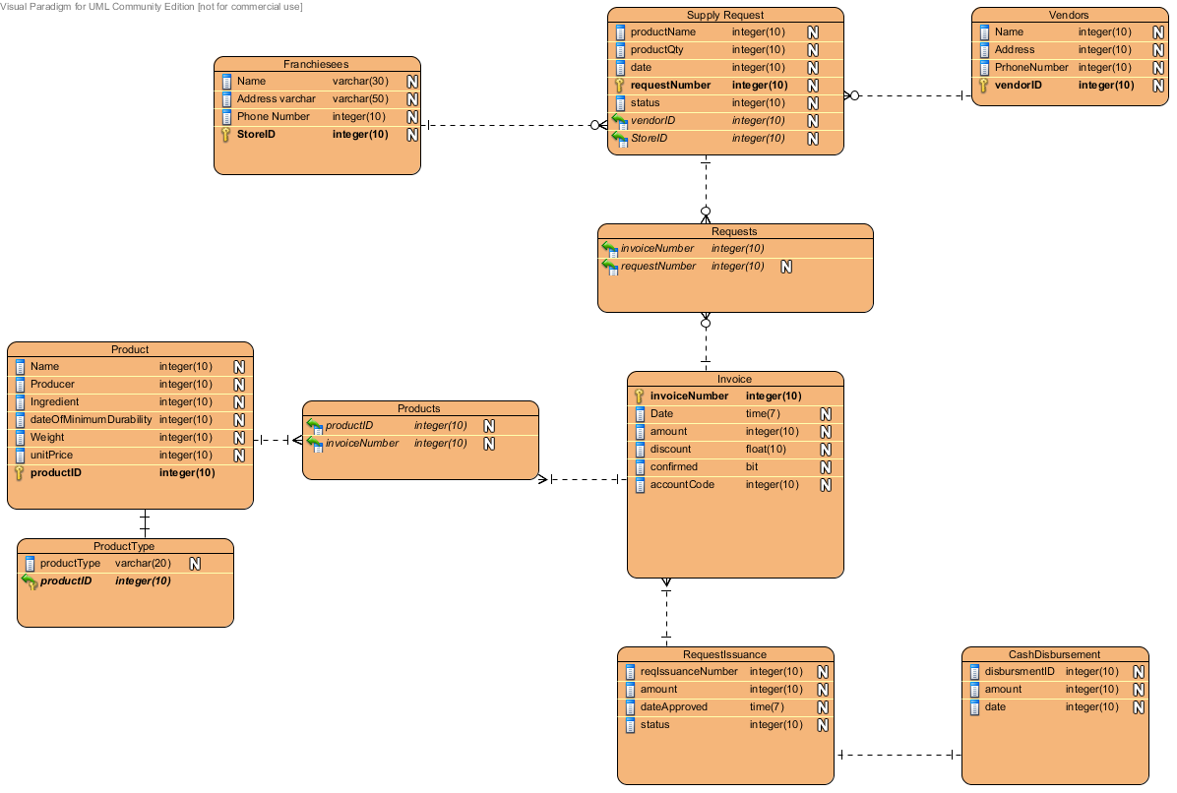

Fig 5.1
This is the database diagram of how to implement the system in SQL. The static types that would be represented in memory by popular programming languages like Java or C# will have their equivalents in SQL languages such as MS SQL or Oracle.
All classes that have many-to-many relationships need to be normalized in SQL, so that there is a lookup table that references the primary keys of the related entities. This was done for the Products and Invoice relationship, which has a “Products” table, and the Invoice and Supply Request relationship, which has a Requests Table.
In our system, we included features to track employee accounts that interact with our system. There are three employees: an accounts payable clerk accounts payable supervisor, and a check issuances clerk. In the SQL implementation, as they all share the same data with exception of the type of employee they are, we added a type field to distinguish this and implement as one table. This is the most optimal information.

6. Navigation Design
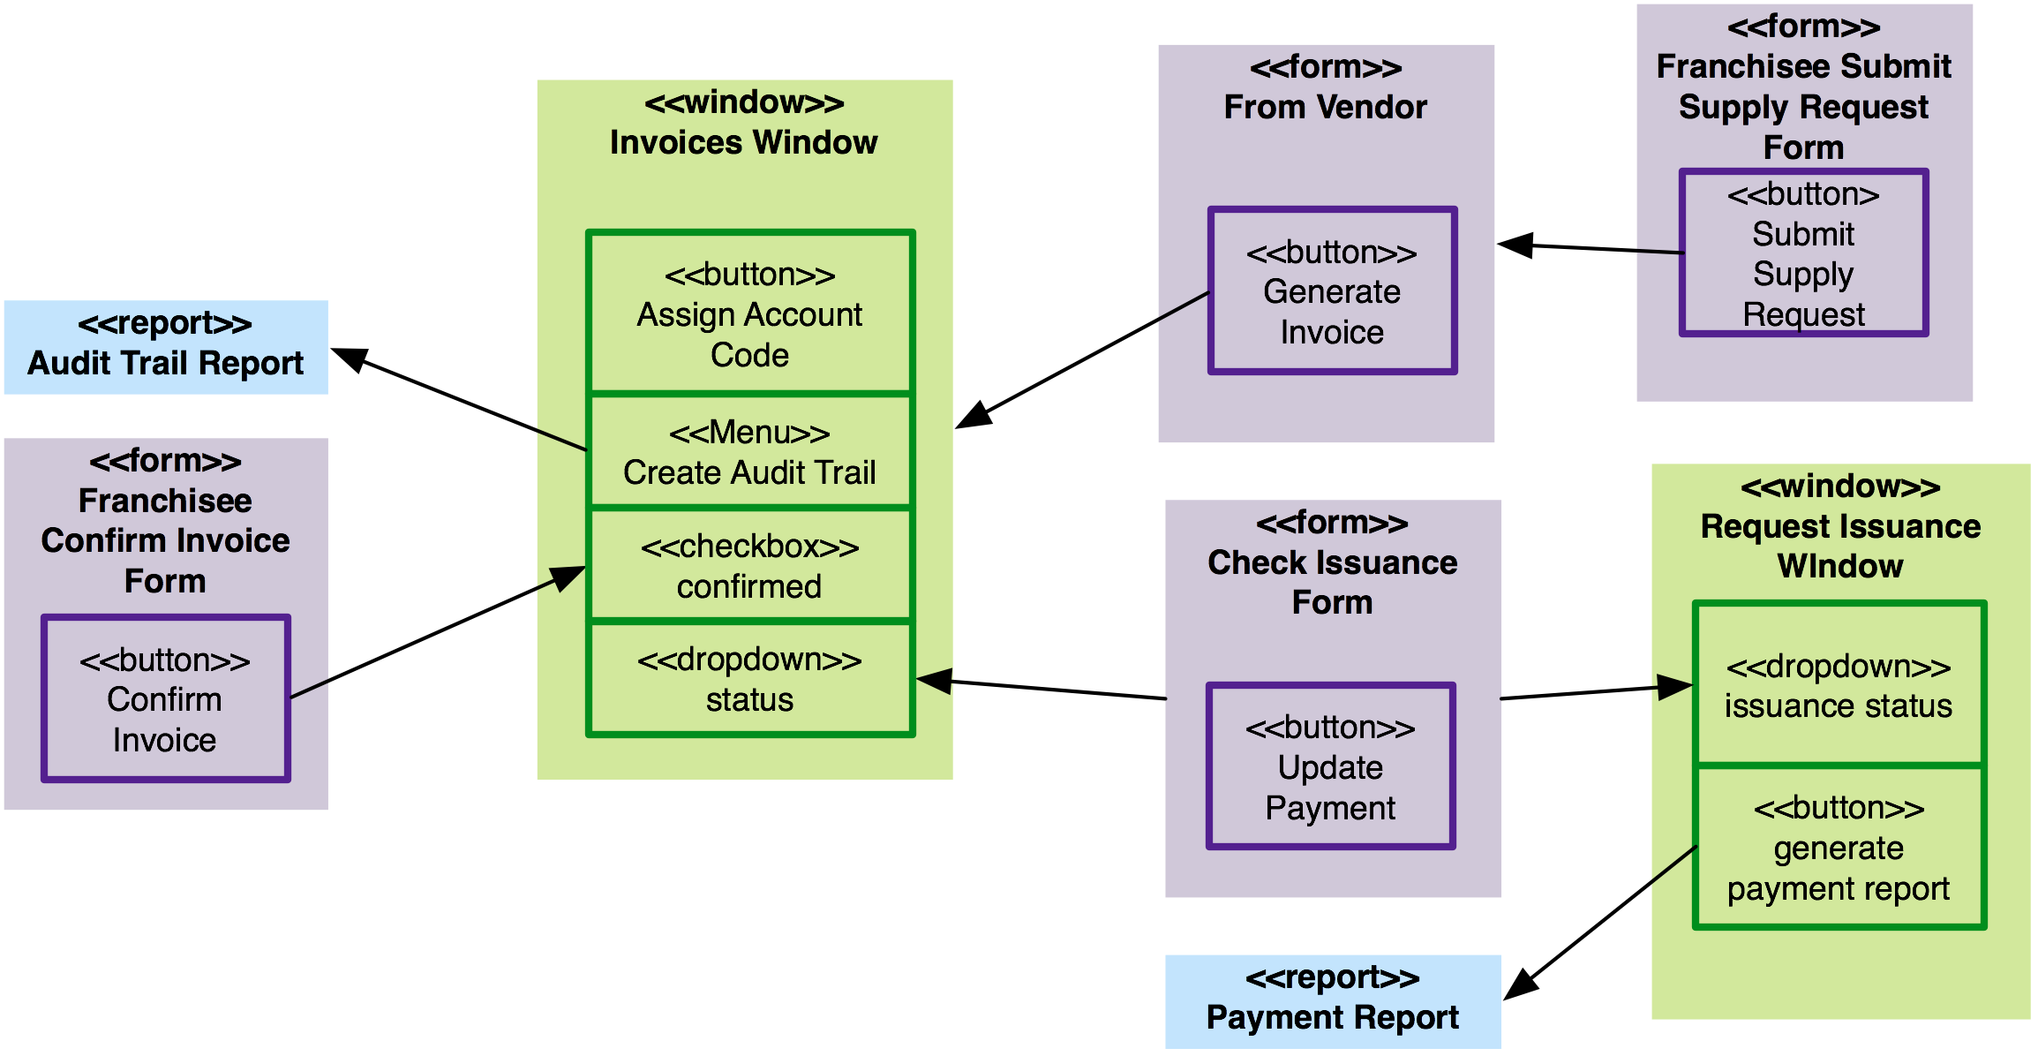
Fig 6.1

This is the Window Navigation System is used to capture the overall transissions between user interfaces in order to show how users transition from one part of the system to another. Our system is dividid preimarly into two categories, web forms used to interact with external third-parties (shown in purple) and an internal desktop application (shown in green) that will be used by accounting staff. The desktop system will generate reports as needed (shown in blue).
An invoice will be generated through a web form interface, which will be submitted to the invoicing system. This occurs after the franchisee generates a supply request through a web form interface called Franchisee Submit Supply Request form, which will send the request electronically to the vendor. Later a franchisee will receive the invoice, typically along with the goods, and then go into the system and confirm the invoice using the web form called Franchisee Confirm Invoice form. This will update the value in the system called confirmed.
The accountants at the college interact with two main windows, one that is a list or aggregate of all the invoices, and another to track whether the invoices are paid out through request issuance process. In the Invoices window, will manage the invoices, assign accounting codes, monitor and update the status, as well as generate audit reports. Another window called Request Issuance will show requests that have been made and all the affiliated invoices that will be paid out. This window will support functionality to generate a payment report. One a check is written and sent to the vendor, the check issuance office can interact with a web form called Check Issuance form, which when filled out and submitted, this will update the system to reflect that the request and affiliated invoices have been paid appropriately.

7. Input Design
- Step 1.
After franchisee log into the system, system will show an invoice list window, as shown in Figure 7.1. Franchisee can click on the cells Vendor#, Vendor Name, Invoice# and Issue Date to sort invoices by their descend orders. Click again change to ascend order. Status can be chosen to show invoices only at a particular status. There is also a search function for users. User can search invoices by vendor number, vendor name and invoice number. Vendor name only can contain letters and the numbers of vendor and invoice have a specific format. An error message will show below the input area if user input invalid format. User can also limit the range of issue date. For example, if user need to find invoices issued on a particular day, they can choose “on this date” option. Then an extra input line will be shown. As shown in Figure 7.2. User can choose date from dropdown box, and input the year. The year must be “yyyy” format, if it is not, system will show an error message to ask user input correct format of year.

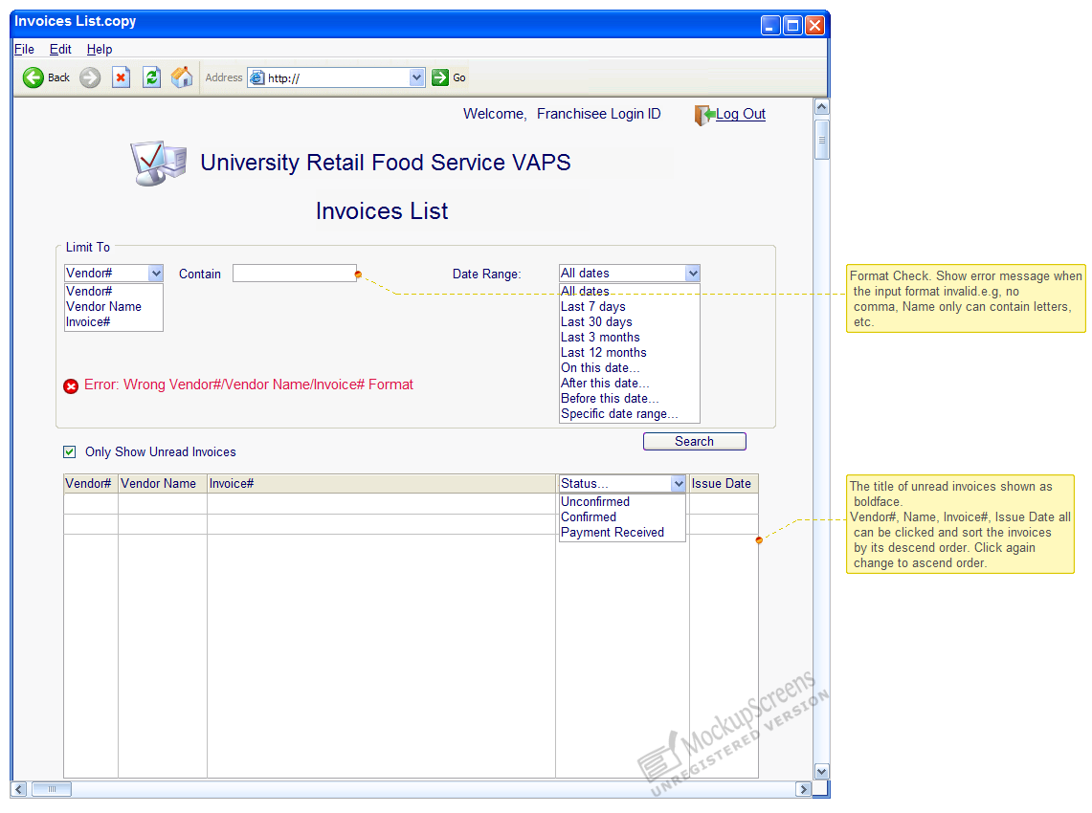
Figure 7.1

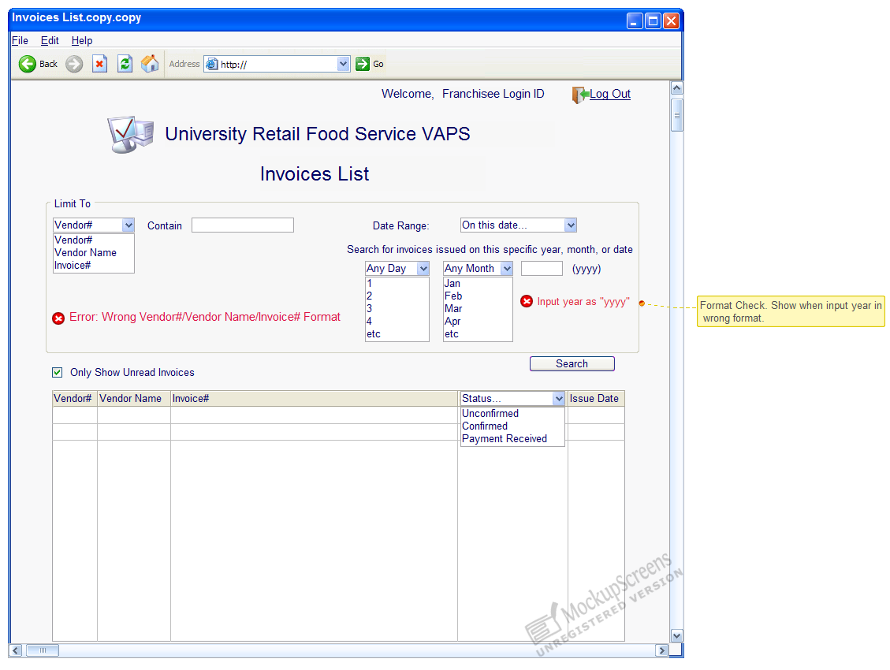
Figure 7.2

- Step 2.
Franchisee confirms the invoice. System will show the invoice number and invoice information as it saved in database previously. Franchisee then check invoice and confirm it if there is no problems. Then system confirms the invoice and sends an invoice confirmation message with confirmation reference number and change the status of invoice to “confirmed”. If there are some missing items, which is a very rare situation, franchisee may click the decline button. Then the input field below the decline button will be valid. User must input decline reason before he send invoice back to vendor. System will show an error message if it cannot find any content entered in the field. As shown in Figure 7.3.
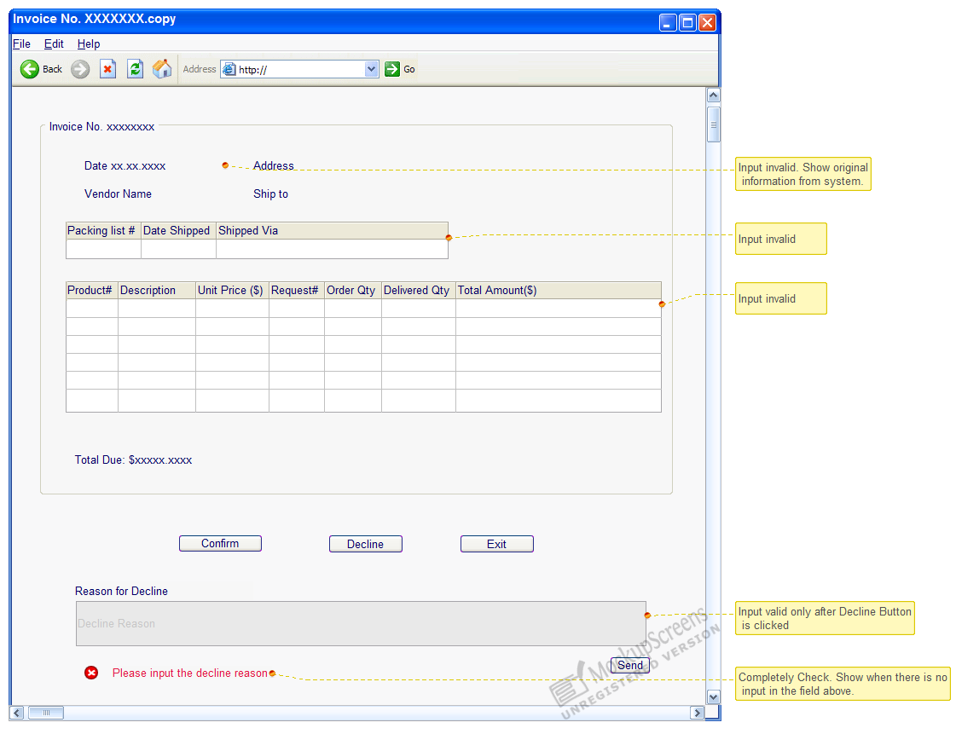
Figure 7.3
8. Output Design

Pending supply requests are the supply requests that have been submitted by the franchisees but the products are not completely received. Pending supply request report is an ad hoc paper output that the franchisee uses to view the summary and details of the pending supply requests. The franchisee manager can generate the report by the system whenever he wants to, but usually he will do this every two days. If the pending supply request runs over 2 days, he may have to contact the vendor.
The report will be printed in A4 paper. Since the report is only for the franchisee manager’s reference, no formal cover paper is needed. Usually one page is enough for the summary part because the number of pending supply requests seldom run over 6 and the details will come in following 1 to 3 pages.
The franchisee’s name appears on the header of the page because the information of the franchisee is just for recognition, instead of a major part of the content. The date on which the report is generated appears on the top right of the first page, which can make it easier to search for report of a certain day.
The first page is the summary of the pending supply request, including brief information of all pending supply requests, arranged in time sequence. The request submitted earliest appears first.
Below the summary table, the total number and ground total amount of all pending supply requests are shown for a quick glance.
Following the summary table, the requests will be grouped by different vendors, total number of pending supply request and subtotal are generated for each vendor.
Details of the requests begin in a separate page. The sequence is the same with the first summary table, for easy reference. For each supply request, first the supply request number and the vendor information will be shown. There is also a filed named status, indicating the status of the request, which can be not delivered, or partially delivered. If partially delivered, in the column of Qty received of the product information table, relative numbers of the products received will be assigned.
Below the table there are three figures. Total Amount is the sum of money of the whole supply request. Total Received is the sum of money of the products received. Pending Amount equals to the number that total amount minus total received.
For different supply requests, the details will be shown in the same format to provide a consistent view.
Pending Supply Request Report
Date: DD/MM/YYYY

Summary
Supply Request No. | Vendor Name (Vendor No.) | Total Amount  (HKD) | Order Time
1001 | XXXX (001) | 600.00 | 23/03/2011 10:25:47
1905 | YYYY (002) | 500.00 | 24/03/2011 12:01:30
2018 | ZZZZ (003) | 250.00 | 25/03/2011 20:00:00
2001 | XXXX (001) | 700.00 | 25/03/2011 20:30:00
2074 | WWWW(004) | 800.00 | 25/03/2011 21:11:56
2088 | YYYY (002) | 600.00 | 26/03/2011 08:13:00
2093 | YYYY (002) | 500.00 | 27/03/2011 12:00:00

Total Pending Supply Request: 7
Total Amount: 3950.00

Vendor Name (Vendor No.) | Supply Request No. | Total pending no. | Total Amount  (HKD) | Subtotal  (HKD) | Ground Total  (HKD)
XXXX (001) | 1001 |  | 600.00 | 1300.00 | 1300.00
XXXX (001) | 2001 | 2 | 700.00 | 1300.00 | 1300.00
YYYY (002) | 1905 |  | 500.00 | 1600.00 | 2900.00
YYYY (002) | 2088 |  | 600.00 | 1600.00 | 2900.00
YYYY (002) | 2093 | 3 | 500.00 | 1600.00 | 2900.00
ZZZZ (003) | 2018 | 1 | 250.00 | 250.00 | 3150.00
WWWW (004) | 2074 | 1 | 800.00 | 800.00 | 3950.00

Details
Supply Request No. Status: not delivered
Vendor Name (Vendor No.):
Vendor Address:
Vendor Email:
Vendor Tel:
Vendor Fax:
Product No. | Product Name | Price  (HKD) | Qty Required | Qty Received | Total Amount  (HKD)
B1000 | Bread1 | 3.00 | 40 | 0 | 120.00
B2032 | Bread2 | 4.00 | 40 | 0 | 160.00
D1015 | Diary1 | 6.00 | 30 | 0 | 180.00
F2901 | Fruit1 | 5.00 | 20 | 0 | 100.00
P1010 | Plastic Bag1 | 0.20 | 200 | 0 | 40.00
Total Amount: 600.00
Total Received: 0.00
Pending Amount: 600.00

Supply Request No. Status: partially delivered
Vendor Name (Vendor No.):
Vendor Address:
Vendor Email:
Vendor Tel:
Vendor Fax:
Product No. | Product Name | Price  (HKD) | Qty Required | Qty Received | Total Amount  (HKD)
B1012 | Bread3 | 2.50 | 40 | 40 | 120.00
D4001 | Diary2 | 4.00 | 30 | 30 | 180.00
R2904 | Rice1 | 40.00 | 5 | 2 | 200.00
Total Amount: 500.00
Total Received: 440.00
Pending Amount: 60.00

